**Digital Logic Design**

**(3+1 Credit Hours)**

(CEN- 120)

Project Report

**DEPARTMENT OF COMPUTER SCIENCE**

BAHRIA UNIVERSITY, KARACHI, PAKISTAN

**Title**

***“IR OBSTACLE SENSOR”***

**Submitted to**

***“Muhammad Zohaib Sohail”***

**Members**

**Hurraira Bhatti (02-134212-019)**

**Anas Ahmed Qureshi (02-134212-042)**

**Sheikh Yasir (02-134212-002)**

**SUBMITTED ON**

**04th July 2022**

**Table of Contents**

1. Abstract -------------------------------------------------

2. Introduction --------------------------------------------

3. Components --------------------------------------------

4. Circuit/ Schematic Diagram -------------------------

5. Working ------------------------------------------------

6. Results --------------------------------------------------

7. Application/Features ---------------------------------

8. Conclusion ---------------------------------------------

9. References ---------------------------------------------

10. Datasheets --------------------------------------------

1. **ABSTRACT:**

So, in this project we are constructing a IR Obstacle sensor without using of any type of Microcontroller. So, in this sensor we use resistors, IR sensor, NPN transistor, buzzer, led, battery, jumper wires on breadboard. We connected it with the and gate IC’s 74LS32 IC to activate the sensor by alarming through buzzer and LED light working.

1. **INTRODUCTION:**

In this project we are going to make an Obstacle sensor without the Help of any Microcontroller. Obstacle sensor have many uses. since we are not using any microcontroller, so this project is cheaper also.

Most importantly we can extend this project to Fire alarm system etc. Only thing we have to do is to change the sensor.

1. **COMPONENTS / TOOLS:**

* Breadboard (1*1)
* IR sensor (1*1)
* NPN transistor (1*1)
* Buzzer (1*1)
* Led (1*1)
* 9v DC battery
* Jumper wires
* IC 74LS32
* Resistor (300ohm,10k ohm)

1. **SCHEMATIC DIAGRAM:**

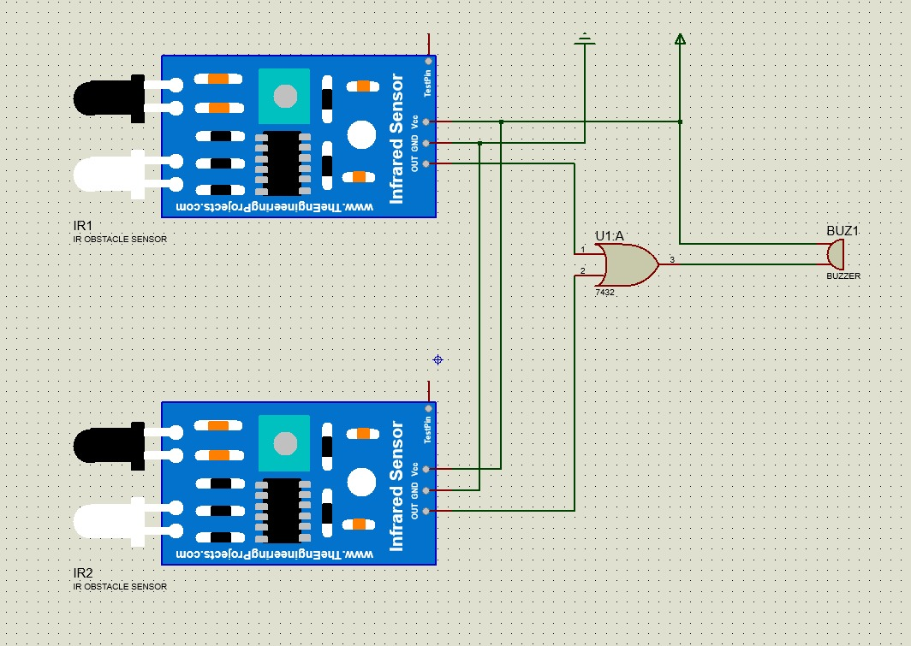

1. **WORKING:**

In IR sensor there are three pins, VCC, Ground and Out. Out pin sends logic high(+5V) when IR detects any Obstacle and It sends Logic Low(0V) when does not Detect any Obstacle.

To use IR sensor, we connect VCC of sensor to Positive terminal of battery, and Ground pin of sensor to negative terminal or ground of the battery.

**Step1:** Connect positive terminal of battery to Positive Rail of Breadboard and Negative terminal of battery to negative rail of breadboard. Positive and negative rail are the topmost and bottommost row of Breadboard.

**Step-2:** Take the NPN transistor and place it on the breadboard. take a look at transistor and note which pin is base, emitter and collector pin.

**Step-3:** Connect emitter of transistor to ground or negative rail of breadboard where negative terminal of battery is connected.

**Step-4:** Connect VCC pin of IR sensor to positive Rail, Ground pin to negative rail of breadboard. Connect Out pin of Sensor to base of the Transistor but in between base and Out pin of sensor connect resistance of value 10K.for this one end of resistance is connected to Base of transistor and second end of resistor is connected to OUT pin of sensor.

**Step-5:** Take a led, Take 330ohm(330-10000hm) resistor. Connect led's ANODE pin to one end of resistor. Connect Second end of Resistor to Positive Rail of Breadboard. and cathode pin of Led to collector of transistor.

similarly Connect positive side of Buzzer to positive rail of breadboard, and negative side to collector of breadboard.

#### **RESULTS:**

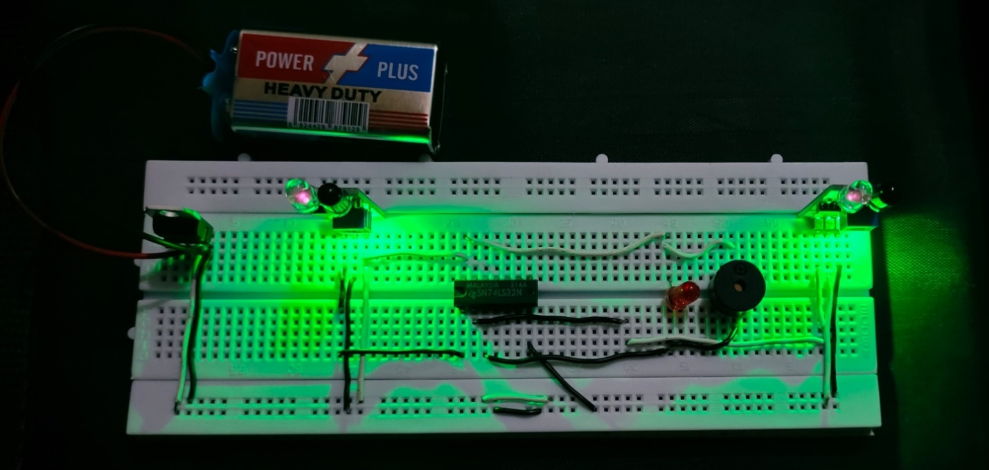

#### **APPLICATION / FEATURES:**

The applications of the infrared sensor include the following.

* Rail Safety
* IR Imaging Devices
* Infrared Astronomy
* Optical Power Meters
* Night Vision Devices
* Sorting Devices
* Moisture Analyzers
* Missile Guidance
* Flame Monitors
* Remote Sensing
* Climatology
* Gas Analyzers
* Meteorology
* Rail safety
* Photobiomodulation
* Exploration of Petroleum
* Flame Monitors
* Testing of Anesthesiology
* Gas detectors
* Moisture Analyzers
* Water analysis

#### **CONCLUSION:**

So, at the end we will discuss that when the sensor sense anything it passes signal the signal to the OR gate which clarifies the value because when the value comes other than true it doesn’t proceed but when the value comes true it turns the LED on and activate the buzzer.

#### **REFERENCES:**

[IR Obstacle Sensor Without Using Arduino or Any Microcontroller : 6 Steps - Instructables](https://www.instructables.com/IR-Obstacle-Sensor-Without-Using-Arduino-or-Any-Mi/)

[IR Proximity Sensor / Obstacle Detector circuit on Breadboard | LM358 Op-Amp projects - YouTube](https://www.youtube.com/watch?v=qEMtCKfZOHw&t=3s)

1. **DATASHEETS:**

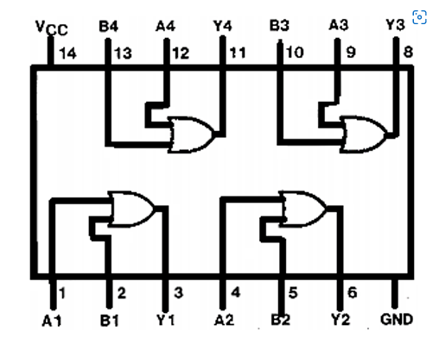

|  |  |  |
| --- | --- | --- |
| **Pin Number** | **Pin Name** | **Description** |
| 1,4,9,12 | OR Gate Input pin (A) | First Input pin for the OR gate |
| 2,5,10,13 | OR Gate Input pin (B) | Second Input pin for the OR gate |
| 3,6,8,11 | OR Gate Output pin (Q) | Output pin for the OR gate |
| 7 | Ground | Connect to the ground of the circuit. |
| 14 | Vcc (Vdd) | Used to power the IC. Typically +5V is used |